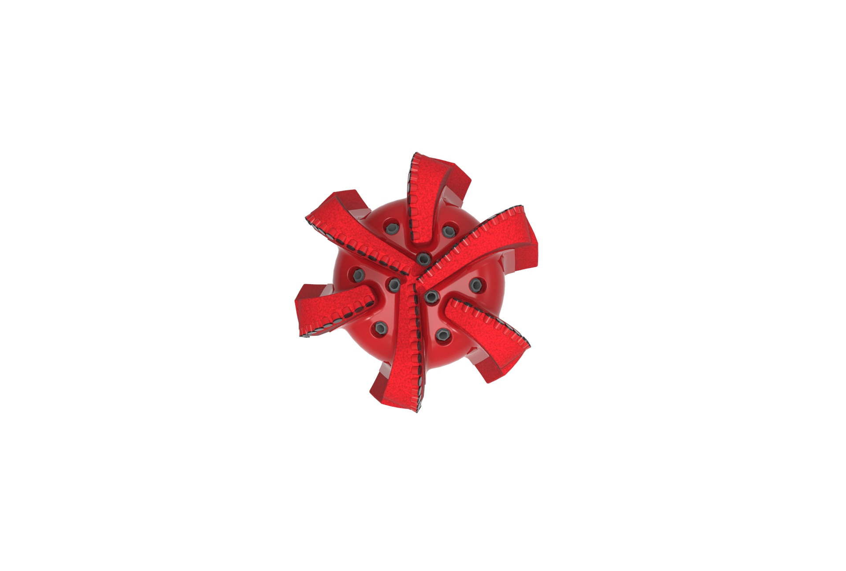
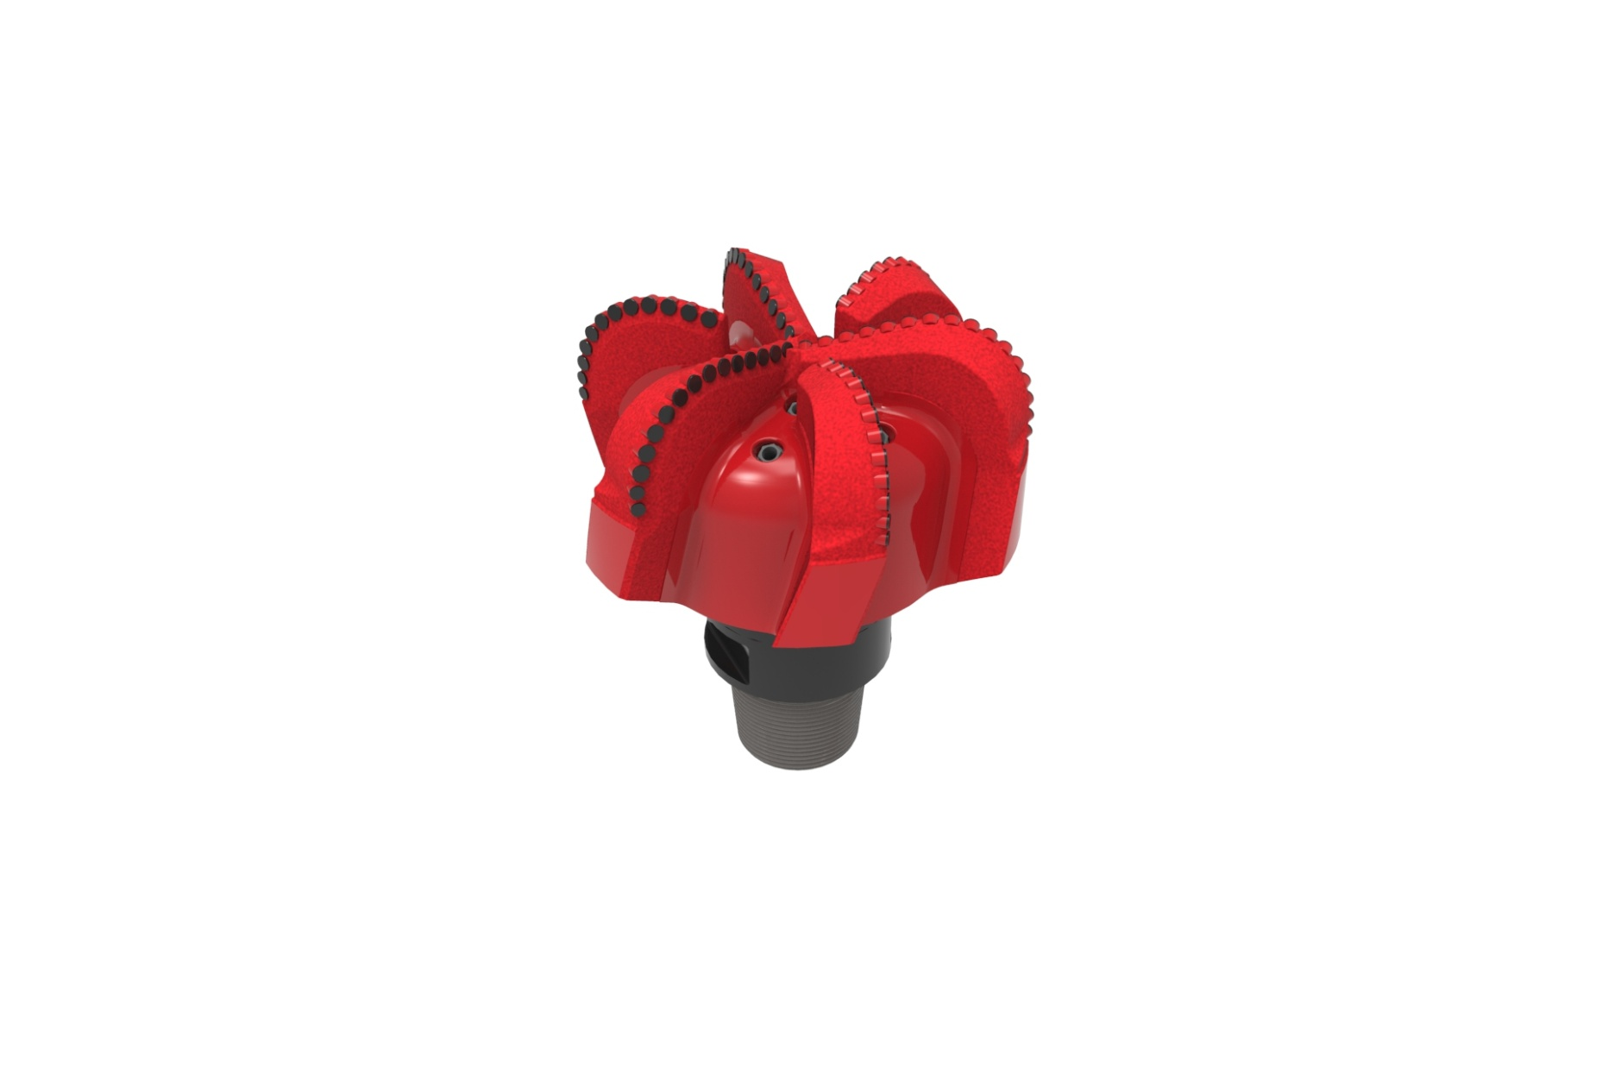

Drill Bit Specifications:
Cutter Size (Primary, Sec) | 5/8”,1/2”
Cutter Count (Total, Gage) | 82,14
Blade Count | 6
Gage Length (Inches) | 3.5
Nozzle Count (Primary, Sec.) | 9
Nozzle Series (Primary, Sec.) | 60
JSA (Sq. Inches) | 83.9
Max. TFA (Sq. Inches) | 3.34
Operating Parameters:
Max. Weight on Bit (1,000 Lbs.) | 66
Make-up Torque (ft/lbs) | 40,500
Nominal Dimensions:
Overall Length (Inches) | 20.25
Make Up Length (Inches) | 15.375
Bit Breaker | SKB-21036
Connection | Ø6-5/8" API Reg.
Approx. Weight (Lbs.) | 420
*Long tool joint available upon request (adds 6” to fishing neck,
makeup and overall length, and 64 lbs to approximate weight).

Standard Features:

- Large open face volume assists cuttings removal
- Nine nozzles optimize blade cleaning and cuttings removal
- Premium grade cutters maximize ROP and Life

616-SR9 Nomenclature Explained:

• | 6 | = | Number of blades
• | 16 | = | Primary Cutter Size (16mm)
• | SR+ | = | Single Row of Cutters
• | 9 | = | Number of Nozzles

*Interchangeable nozzles.

